Pig Project:

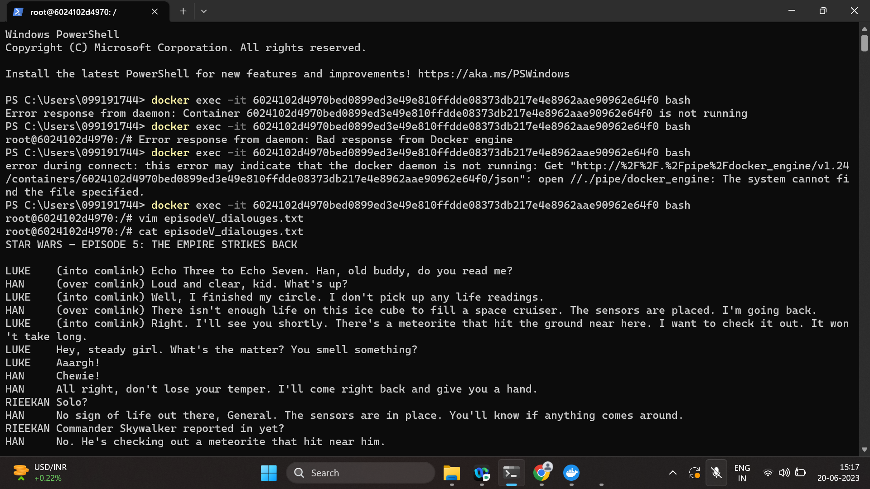

Output:

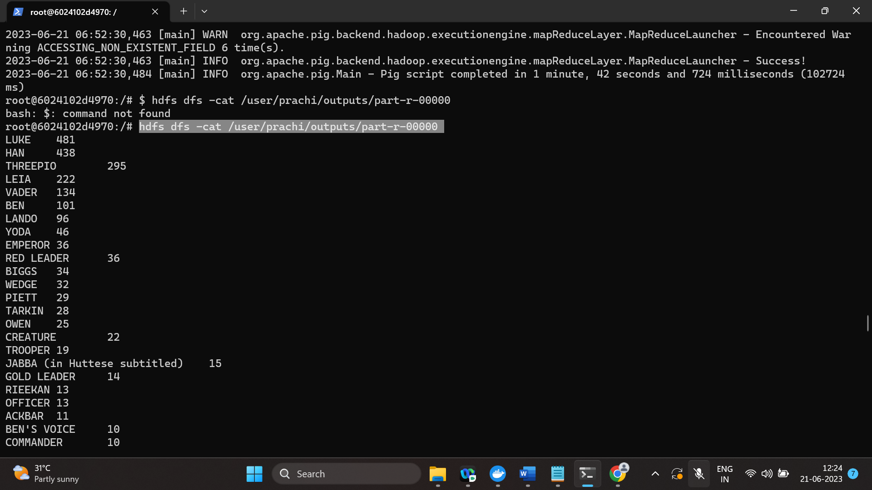

Copy:

